**EX#1 – Cooling wall with equal boundary temperatures**

Problem Statement

After having calculated the exact solution of a sudden, symmetric cooling of a wall, create a model of this same situation, but with multiple nodes. Assume that the wall is constructed of stainless steel and has a height that is a lot larger than the thickness. Compare these two models and plot their respective temperatures against each other at multiple points of time – how close are they? Lastly, create an algorithm that generates the impedance matrix and forcing vector for an adjustable *n* number of nodes and increase until you have a suitable curve that matches the exact solution.

Given

1. Initial wall temperature is 37ªC.
2. Initial boundary temperatures taken to be 25°C.
3. Wall is 0.5 meters thick.

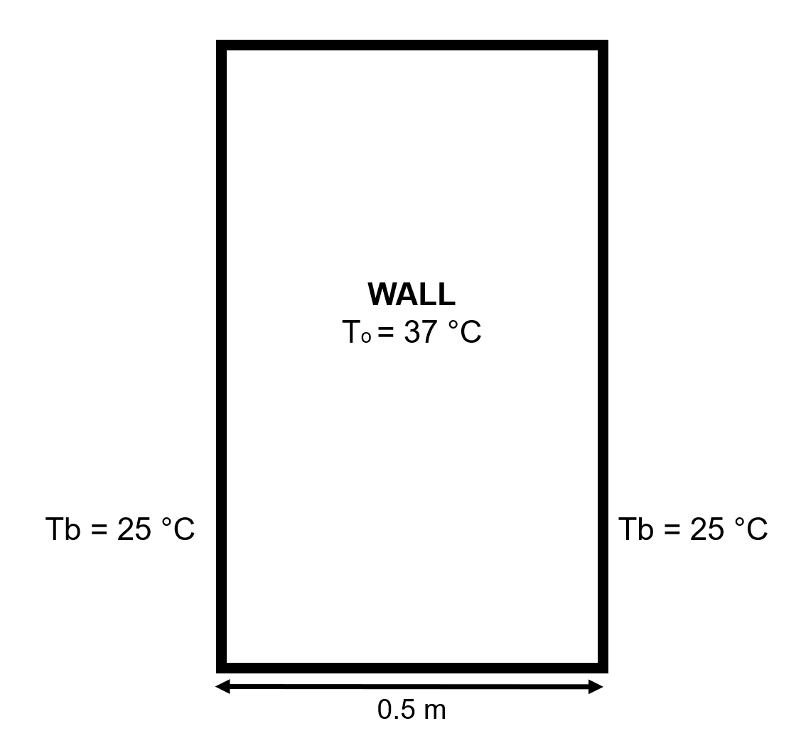

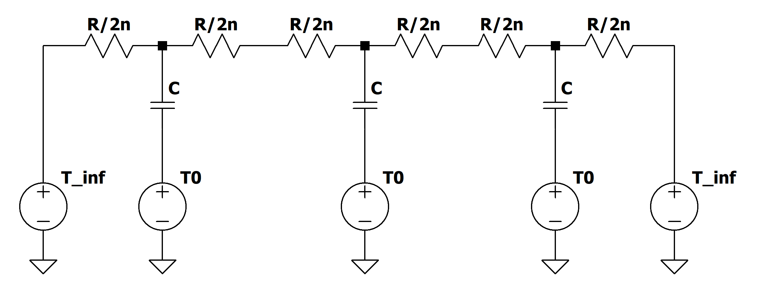

*Fig.1 Schematic and Thermal Circuit Diagram for a Wall with three nodes*

Results & Analysis

a)

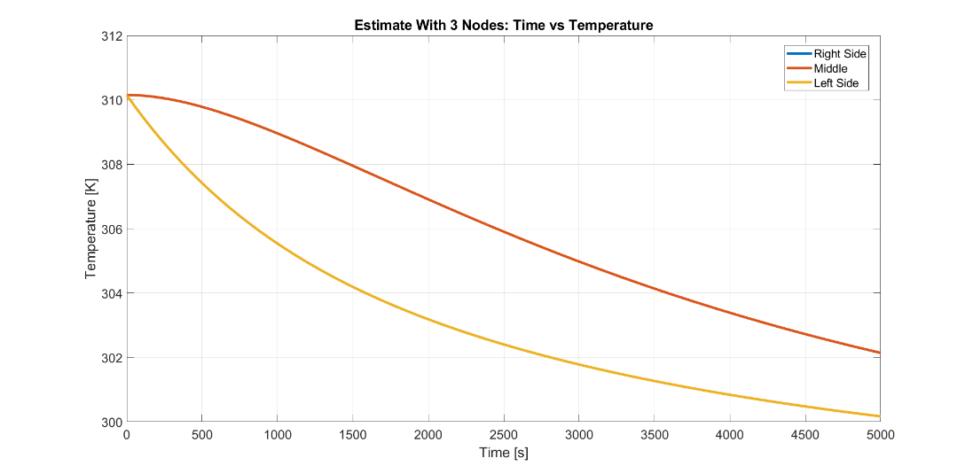

*Fig. 2: Estimate Model Using 3 Nodes*

The plot above demonstrates the estimated temperature using a very small number of nodes. The temperature curves all start at 310 K – the initial temperature of the wall as given – and end at around 300 K and around 302 K with the middle section having the higher ending temperature. This plot makes sense due to the symmetry of the wall – the right and left sides shouldn’t display any different temperature behavior as functions of time.

b)

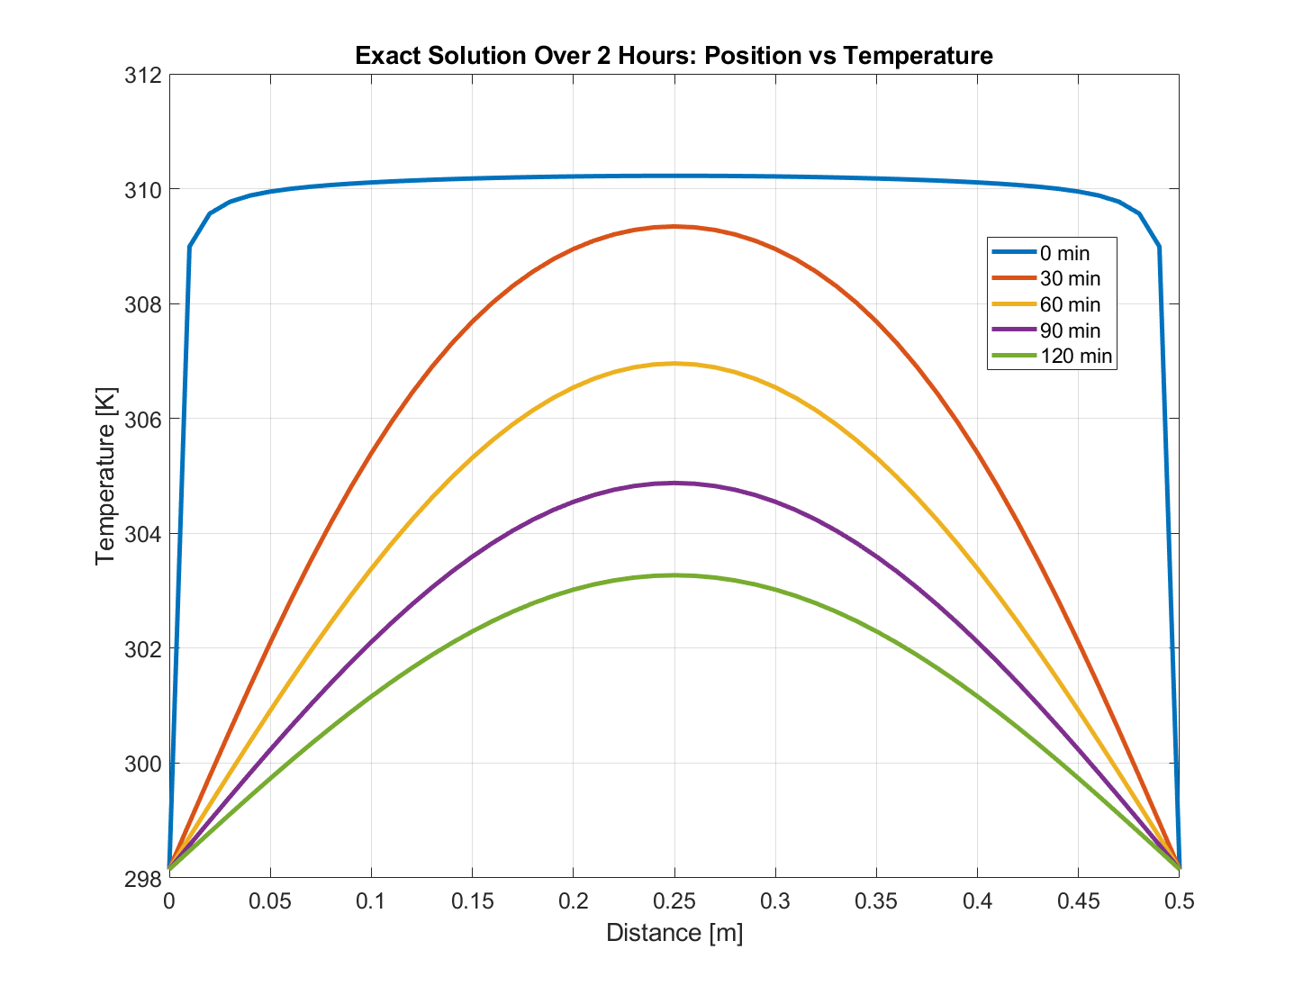

*Fig. 3: Plotting the Temperature Gradient Using the Exact Solution*

The figure above demonstrates the change of the temperature gradient over time based on the Exact Solution. The exact solution is a function of distance and time, so as the distance and time changes, the temperature changes. We plotted the curves at the initial condition, and at half-hour increments up to two hours. As shown by the plot, the initial condition has a very boxy look and reflects that the entire wall starts at 310 K with a sudden transition at the borders (at x = 0 and x = 0.5) to 298 K. As time progresses, however, the metal cools with the parts closest to the borders cooling faster than the middle. The longer the metal takes to cool, the lower the curvature until the entire metal wall reaches thermal equilibrium at the ambient temperature – 298 K.

c) 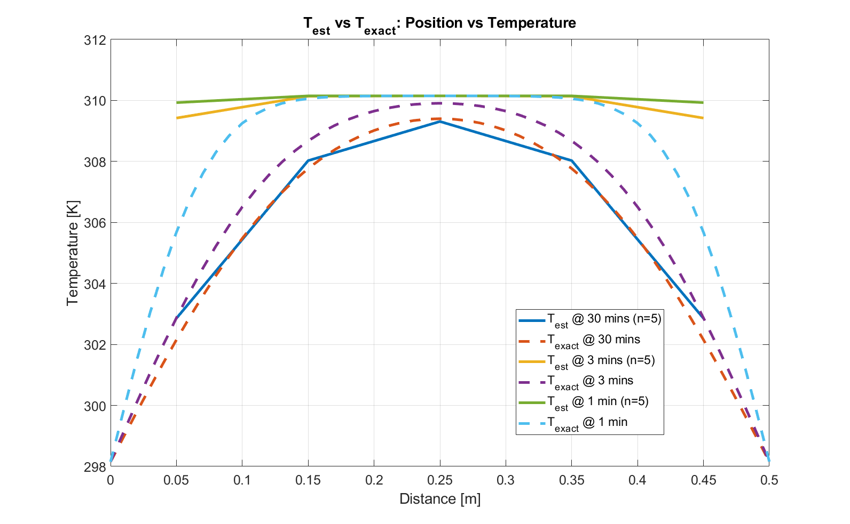

*Fig. 4: Plotting the Temperature Gradient of Exact and Estimated (n=5) Solution*

Even with a low number of nodes, the general shape still follows the exact solution, albeit not accurately. As nodes increase in magnitude (from 5 to 10 and up), the curve gets smoother and more closely displays what the estimated model looks like (see part d). Increasing the node number past a point, however, results in an inaccurate curve due to numerical instability as discussed in class.

d)

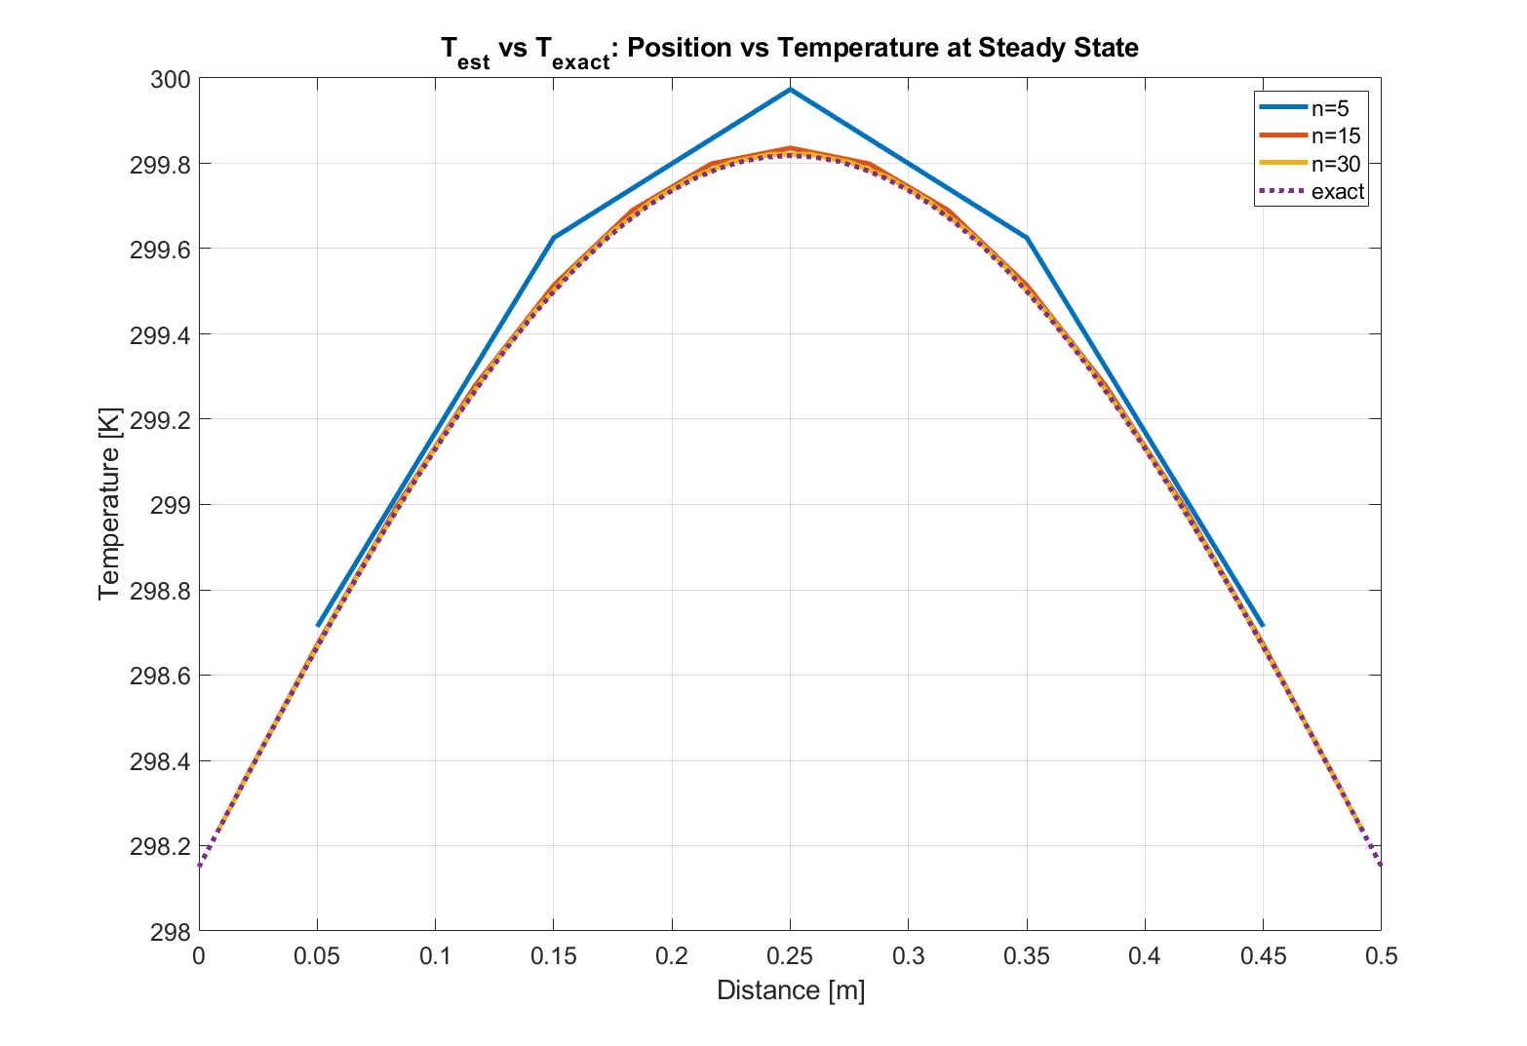*Fig. 5: Temperature Gradient of Different Number of Nodes versus Exact Solution*

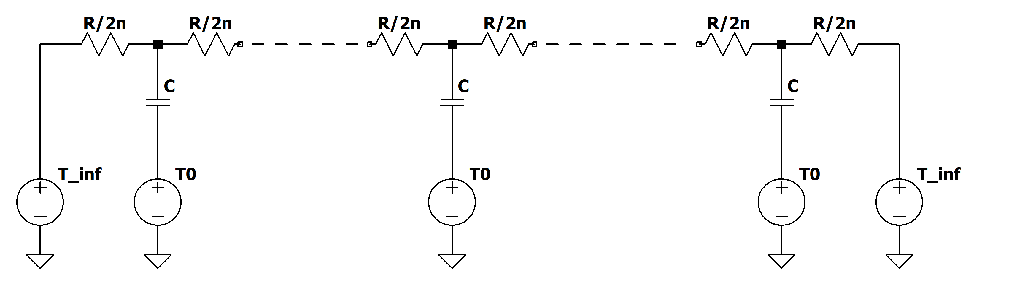

*Fig. 6: Schematic of high number of nodes*

The figure above shows a general circuit that accounts for an ‘n’ value of nodes, as represented in the algorithm. The nodes between the boundaries and the central node all follow the same form, so while choosing a number of nodes, we account for this uniformity by appending the vector for the additional nodes.

**EX #2 – Heating Piston**

Problem Statement

Plot the amplitude of temperature variation in a steel piston cylinder wall that encounters an oscillating surface temperature versus depth. If the cylinder is only 1 cm thick, can we approximate it as having an infinite depth?

Assume the height of the piston to be 0.15m, and width of the piston wall to be 0.06*2*pi (radius of the piston). The temperature response for thickness of 0.001m and 0.01m are measured.

Given

1. The oscillating surface temperature follows: $T=650℃+\left(300℃\right)∙cos⁡(ωt)$

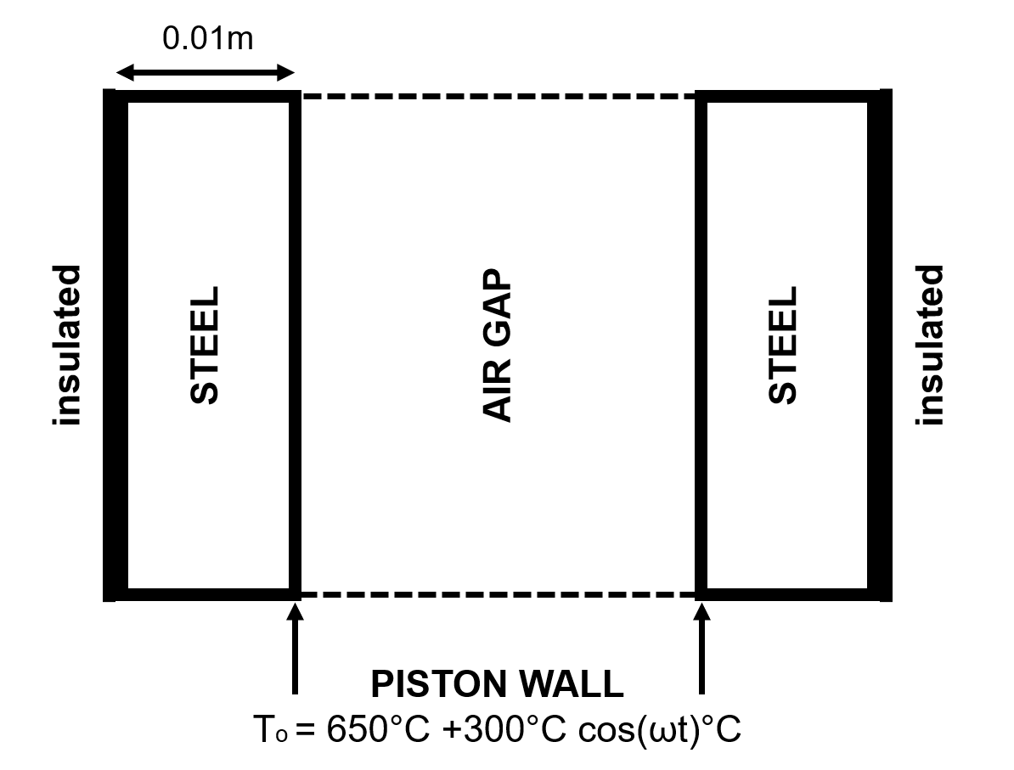

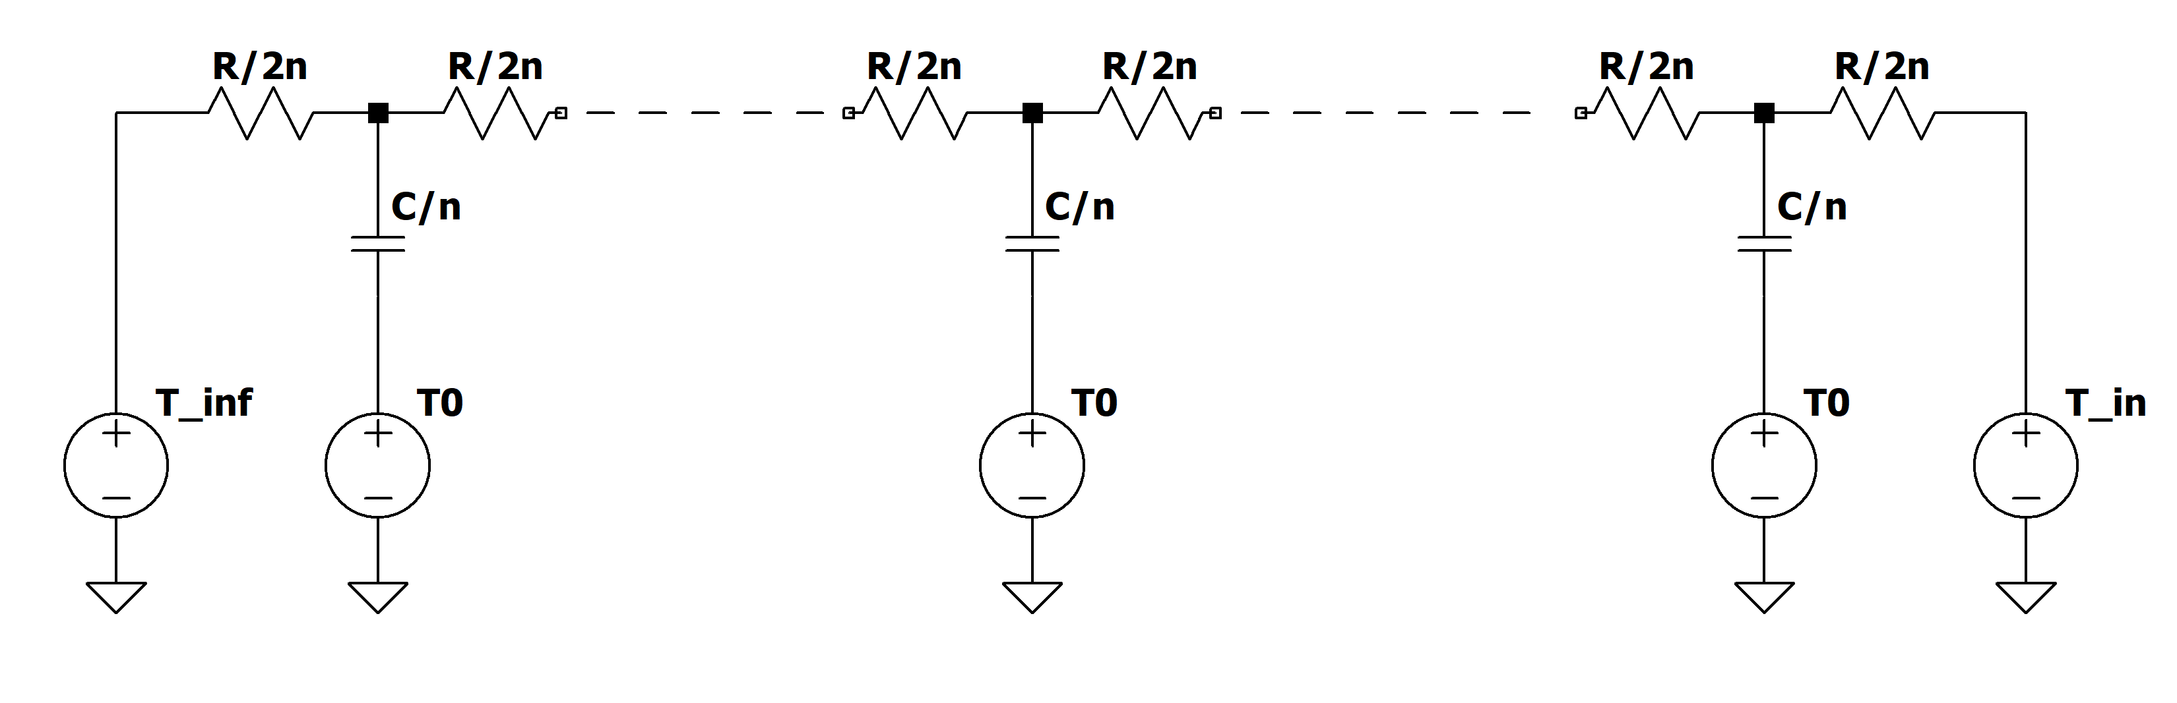

Fig.1 Schematic and Thermal Circuit Diagram for Piston Cylinder

a)

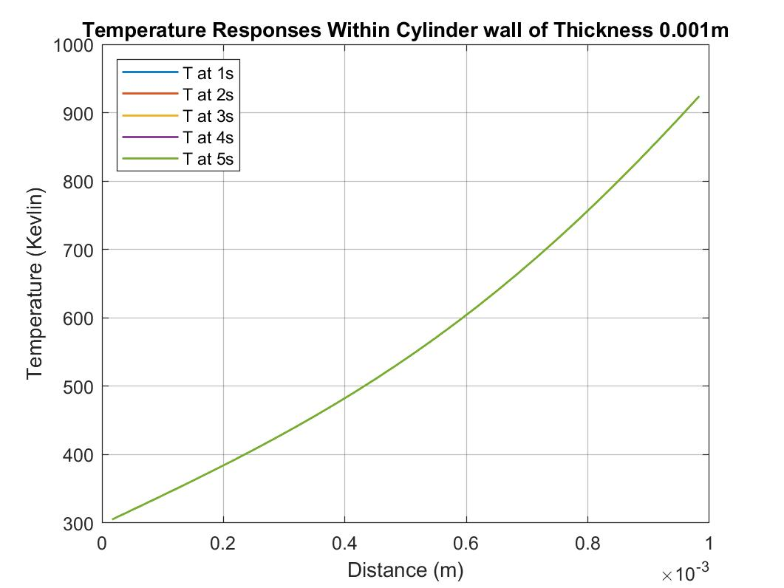

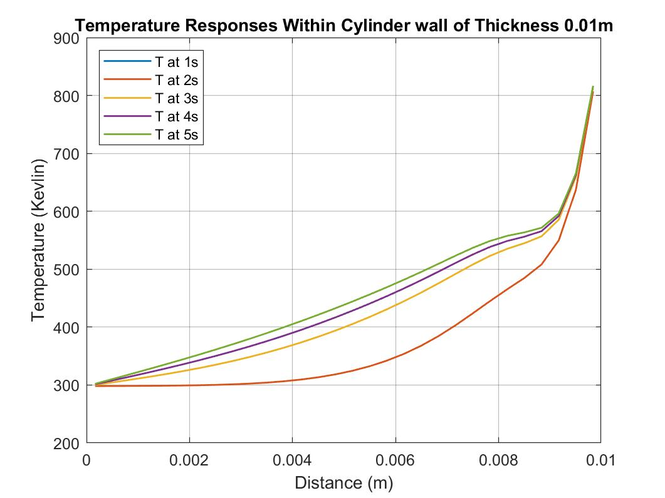

*Fig.8: Temperature Response Inside the Wall at Different Times When Driven Temperatures are In Phase*

Due to the symmetry of the piston, half of the wall is analyzed.

When the wall thickness is 0.001m, referring to first part of Fig.7, it clearly shows that the temperature distribution is the same inside the wall at different time when the driving temperature are in phase (In this case, the time is multiples of 1 seconds). When the thickness increased to 0.01m, the temperature distribution inside the piston wall doesn’t concur with each other anymore, even when the driven temperature are in phase. This is because there is heat transfer delay due to increased thickness.

b) When the thickness of the cylinder is 1 cm, we cannot assume the piston wall is infinitely tall, since the boundary condition at the top and bottom of the wall will affect the heat transfer inside the section of the piston wall being analyzed.

Appendix

EX#1

clc; clear all; close all;

n=30;

%%PARAMETERS

T0=37+273.15;

Tinf=25+273.15;

k=14.4; %conductivity

T=0.5; %m

dT=T/n;

W=1000; %m

H=1000; %m

c=500;

rho=7700;%density

C=c*dT*W*H*rho; %capacity

R=dT/(k*W*H*2); %resistance

%%IMPEDENCE MATRIX

%first term

s=tf('s');

A1=[(1/R)+(1/(2*R))+s*C,-1/(2*R)];

for num =3:n

A1=[A1,0];

end

A=A1;

%middle term

for elem=2:n-1

Amid=[];

for zeroL=1:elem-2

Amid=[Amid,0];

end

Amid=[Amid,-1/(2*R),(1/R)+s*C,-1/(2*R)];

for zeroR=elem:n-2

Amid=[Amid,0];

end

A=cat(1,A,Amid);

end

%end term

An=[];

for num=1:n-2

An=[An,0];

end

An=[An,-1/(2*R),(1/(2*R))+(1/R)+s*C];

%combine terms

A=cat(1,A,An);

%% FORCING MATRIX

B=[((Tinf/s)/R)+(T0/s)*s*C];

for step=2:n-1

B=[B,(T0/s)*s*C];

end

B=[B,((Tinf/s)/R)+(T0/s)*s*C].';

%% SOL FOR MULTIPLE NODES

Twall_s=A\B;

%% PLOT TEMP RESPONSE

t_final=30000;

dt=5;

t=(0:dt:t_final).';

figure(1)

Twall_t=impulse(Twall_s,t);

% plot(t,Twall_t)

%plot for sub slabs

% twall=Twall_t(1000,1)

%create x array

x_axis=[dT/2];

for inter=1:1:n-1

x_axis=[x_axis,inter*dT+dT/2];

end

y_axis=[];

for inter=1:1:n

y_axis=[y_axis,Twall_t(3000,inter)];

end

plot(x_axis,y_axis)

hold on

%% EXACT SOLUTION

alph=k/(rho*c);

K=101;

x=0:0.01:0.5;

for t=15000

y=0;

for k=1:2:K

Cn=4*(T0-Tinf)/(k*pi);

y=y+Cn*exp(-alph*(k*pi/0.5)^2*t)*sin((k*pi)*x/0.5);

end

y=y+Tinf;

plot(x,y)

end

EX#2

clc; clear all; close all;

s=tf('s');

n=50;

%%PARAMETERS

T0=25+273.15;

Tinf=25+273.15;

Tin_s=(650/s)+(300*s/(s^2+64*pi^2)); %internal temp in laplace domain

k=14.4; %conductivity

T=0.01; %m

dT=T/n;

W=1000; %m

H=1000; %m

c=500;

rho=7700;%density

C=c*dT*W*H*rho; %capacity

R=dT/(k*W*H*2); %resistance

%%IMPEDENCE MATRIX

%first term

A1=[(1/R)+(1/(2*R))+s*C,-1/(2*R)];

for num =3:n

A1=[A1,0];

end

A=A1;

%middle term

for elem=2:n-1

Amid=[];

for zeroL=1:elem-2

Amid=[Amid,0];

end

Amid=[Amid,-1/(2*R),(1/R)+s*C,-1/(2*R)];

for zeroR=elem:n-2

Amid=[Amid,0];

end

A=cat(1,A,Amid);

end

%end term

An=[];

for num=1:n-2

An=[An,0];

end

An=[An,-1/(2*R),(1/(2*R))+(1/R)+s*C];

%combine terms

A=cat(1,A,An);

%% FORCING MATRIX

B=[((Tinf/s)/R)+(T0/s)*s*C];

for step=2:n-1

B=[B,(T0/s)*s*C];

end

B=[B,((Tin_s)/R)+(T0/s)*s*C].';

%% SOL FOR MULTIPLE NODES

Twall_s=A\B;

%% PLOT TEMP RESPONSE

t_final=5;

dt=0.01;

t=(0:dt:t_final).';

figure(1)

Twall_t=impulse(Twall_s,t);

% plot(t,Twall_t)

% impulse(Tin_s)

%plot for sub slabs

% twall=Twall_t(1000,1)

%create x array

x_axis=[dT/2];

for inter=1:1:n-1

x_axis=[x_axis,inter*dT+dT/2];

end

y_axis=[];

for inter=1:1:n

y_axis=[y_axis,Twall_t(310,inter)];

end

plot(x_axis,y_axis)

hold on